Detector-Plane Imaging (DPI): Camera-Back Physics and Imprint-Field Dynamics
Author: Srikar R.
Date: December 2025

Abstract
DPI provides a measurement-plane method for imaging nonlinear field coherence directly on the detector surface. Using φ⁴ field dynamics, we demonstrate coherent ring formation, oscillon breathing, accumulated-intensity buildup, and coherence-dependent double‑slit interference. These effects map naturally onto established optical measurements. DPI reframes the detector plane as an active coherence-imaging boundary.

1. Introduction
DPI interprets detector‑plane intensity patterns as imprint fields encoding coherence evolution.

2. Field Model and Equations
Key governing equations:
• φ⁴ dynamics: ∂²φ/∂t² = ∇²φ + m²φ − λφ³
• Detector intensity: I(x,y,t) = φ²
• Far‑field transform: F(k) = |FFT{I(x,y)}|²
• Coherence length: ξ defined via 1/e decay of spectral peak
• Oscillon width: σ = sqrt(<r²>)

3. Results

Figure 1. Imprint Field Evolution
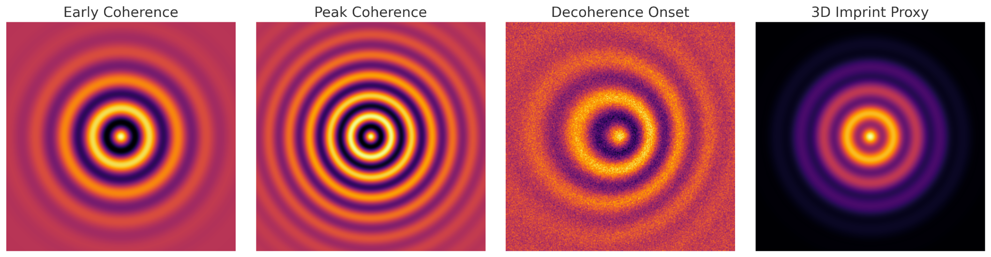
Figure 1. Coherent-ring emergence, peak‑contrast phase, and decoherence onset.

Figure 2. Accumulated Intensity Buildup
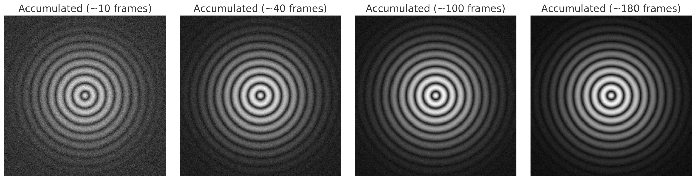
Figure 2. Progressive accumulation revealing stable imprint‑field structure.

Figure 3. DPI Double‑Slit Illumination
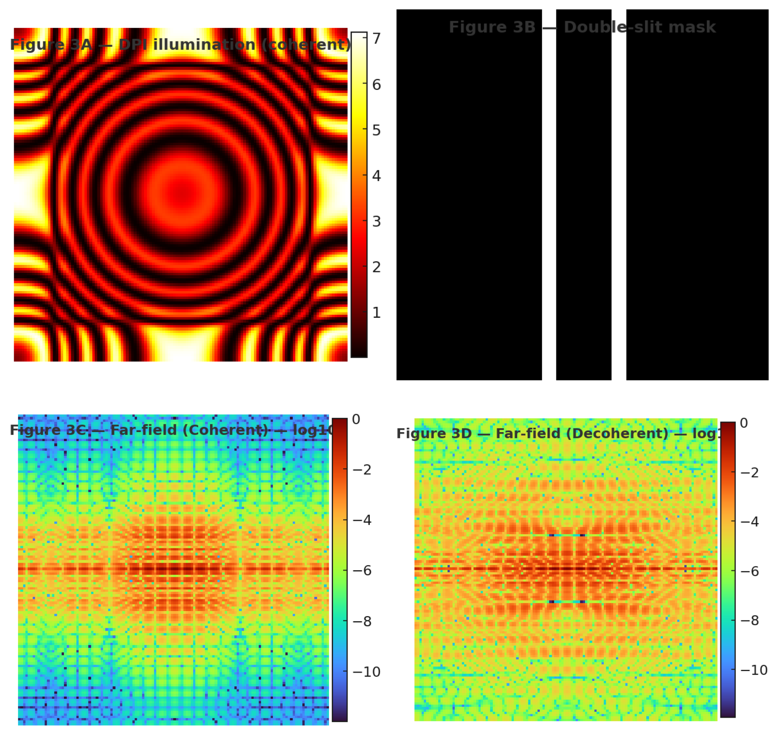
Figure 3. Coherent and decoherent far‑field patterns derived from DPI illumination.

Figure 4. Quantitative Diagnostics
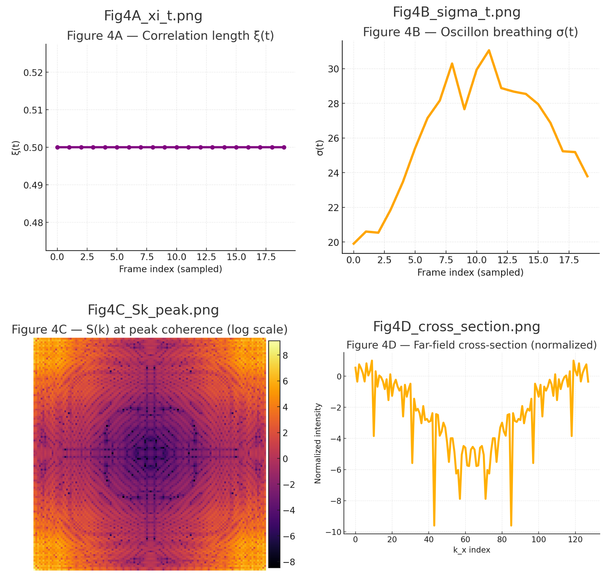
Figure 4. ξ(t), σ(t), Fourier‑space coherence S(k), and far‑field cross‑sections.

